UGANDA NATIONAL EXAMINATION BOARD
UGANDA CERTIFICATE OF LOWER SECONDARY EDUCATION
SHALOM HIGH SCHOOL


END OF YEAR ASSESSEMENT TESTE 2022
GEOGRAPHY SENIOR TWO
TIME: 2 HOURS
INSTRUCTIONS
Attempt only four questions
All questions carry equal marks
Any addition number will not be marked
Draw relative examples when required

1.Assuming you have been given four invitations letters this coming holiday from your friends living Diaspora .Sarah is living in democratic republic of Congo, Abdullah in Egypt , Donnie in England and Namelok in Kenya
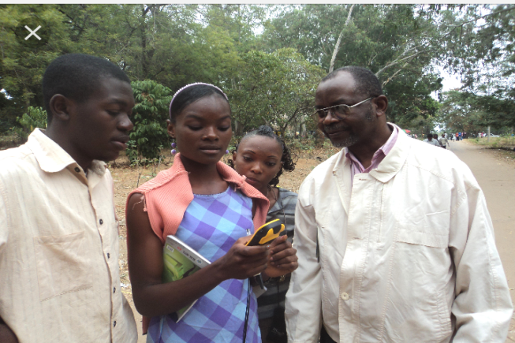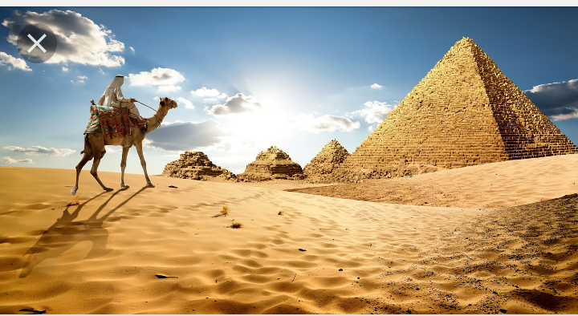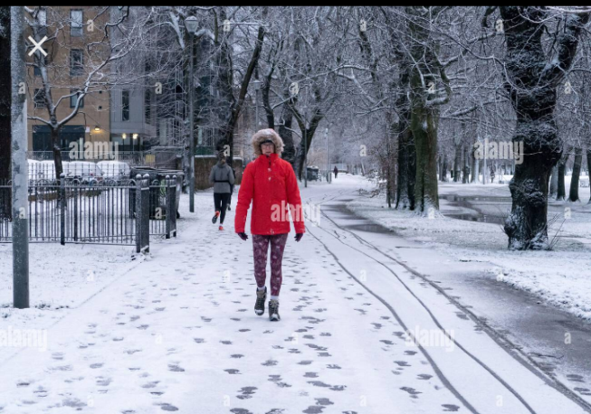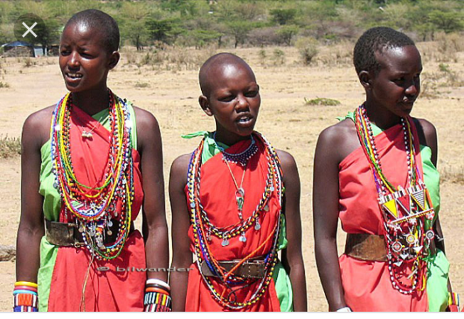
(a) Name the types of climate you are more likely to experience during your visitations.( 04 marks)
(b) Explain the characteristics of those climates.(08 marks)
(c) Since you learnt these types of climate in your geography .How does these climates affect the way of life of the natives. (05 marks)
(d) What are some of the factors that influenced climate of these places? ( 03 marks)
2. Tugume peter is un employed man who lives in small village of rweihamba .of recent he has sold his maize,he has a feeling that maize wont earn him the required money to sustain his way of life. He has got an idea of starting up a business of buying and selling fish. Mr Tugume peter looks to be short of knowledge about it. As student of geography please help him.
(a) Tell him the landing sites we have and there location, so that he is able to know where to buy them ( 03 marks)
(b) What are the factors affecting the development of the business peter wants to engage in.( 06 marks)
(c) Besides only peter gaining, how is the country gaining in the business ( 06 marks)
(d) What are the problems facing the new business peter wants to engage in.( 05 marks)
3. Uganda is the pearl of Africa; this is because of its beautiful climate, hosipitable people, landscape, mountains and rivers, among many others
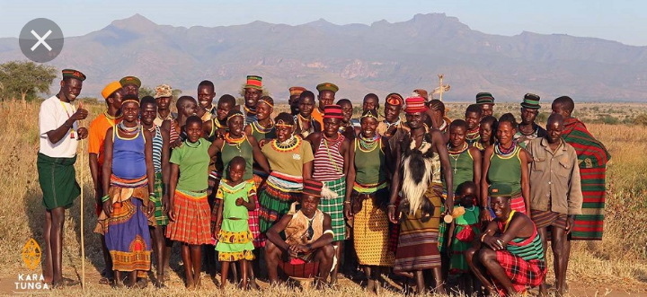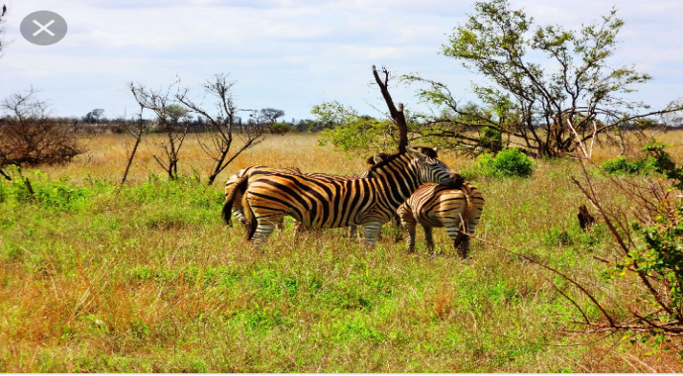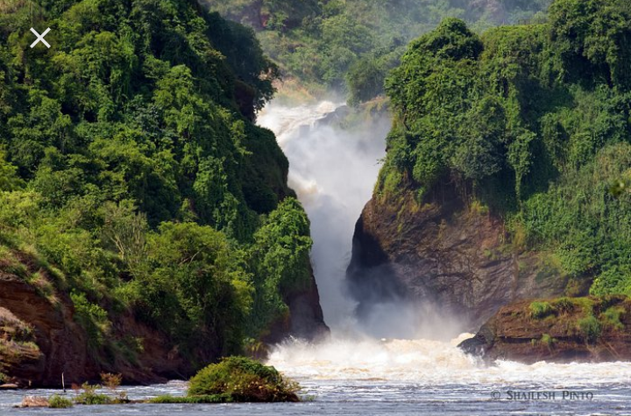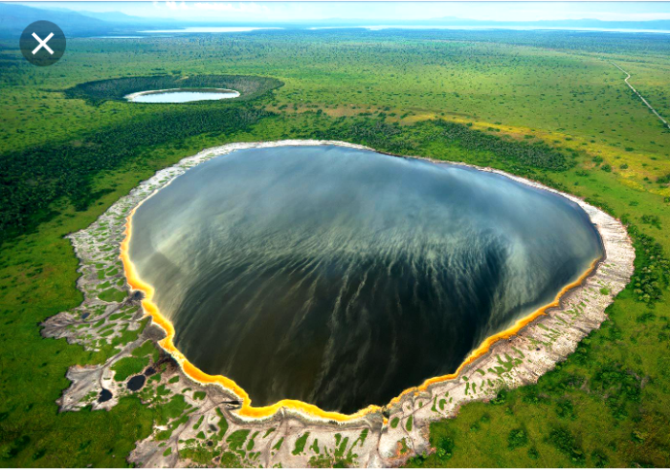
(a) Why should Uganda continue to protect its name? ( 04 marks)
(b) Explain why Uganda receives many whites (05 marks)
(c) Write five places where they mostly visit (04 marks)
(d) What are some of the challenges that Uganda is facing when protecting its name.( 04 marks)
(e) What are some of problems that Uganda is facing because of the coming of many whites? ( 03 marks)
4.the current population of Uganda is 48,857,085 as October 27,2022 ,based on interpolation of the latest united nations data .many people live in rural areas and few in urban places
Below is the table showing some populations of different places in Uganda
AREAS | POPULATION
Enttebe | 79,700
Moroto | 103,432
Kampala | 3,470,000
Fort portal | 60,800
Bulisa | 5,800
(a) Draw a bar graph to represent the information in the table .( 08 marks )
(b) What are the factors that may have influenced the population distribution above? ( 04 marks)
(c) What are the problems that is Kampala facing due to high population( 04 marks)
(d) Explain the factors influencing population growth in Uganda( 04 marks)
5. Assuming you have been appointed as a community leader in the area you come from and the first thing you like to improve is transport and communication
(a) Explain four types of transport you would begin with ( 04 marks)
(b) Explain are the factors that you consider when constructing new transport routs ( 06 marks)
(c) Explain the importance’s of having all weather roads in East Africa ( 06 marks)
(d) Describe the challenges Uganda is facing when developing the transport sector (04 marks)
Merry Christmas and happy New Year

